**Ideation Phase**

**Define the Problem Statements**

|  |  |
| --- | --- |
| TEAM LEAD | S.SATHISH |
| NM ID | D3AB4E60998F2BBA802428A0FF7D9B00 |
| PROJECT NAME | How to create a landing page in HubSpot |

**Customer Problem Statement Template:**

Create a problem statement to understand your customer's point of view. The Customer Problem Statement template helps you focus on what matters to create experiences people will love.

A well-articulated customer problem statement allows you and your team to find the ideal solution for the challenges your customers face. Throughout the process, you’ll also be able to empathize with your customers, which helps you better understand how they perceive your product or service.

**The Problem Statement in creating a landing page in HubSpot:**

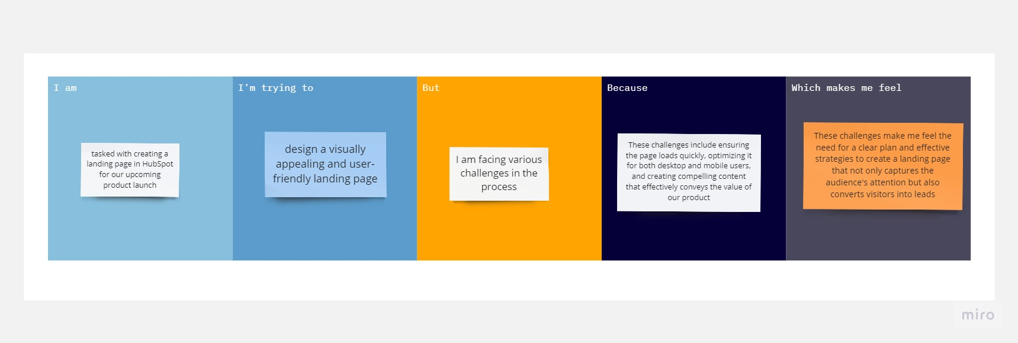

**REFERENCE LINK:**

<https://miro.com/app/board/uXjVMLRn6Jo=/?share_link_id=61727472141>

The various problem statements are defined by the various persons related to workers health and safety are tabulated below:

|  |  |  |  |  |  |
| --- | --- | --- | --- | --- | --- |
| **Problem Statement (PS)** | **I am (Customer)** | **I’m trying to** | **But** | **Because** | **Which makes me feel** |
| PS-1 | Landing page creator | design a visually appealing and user-friendly landing page | I am facing various challenges in the process | These challenges include ensuring the page loads quickly, optimizing it for both desktop and mobile users, and creating compelling content that effectively conveys the value of our product | These challenges make me feel the need for a clear plan and effective strategies to create a landing page that not only captures the audience's attention but also converts visitors into leads |